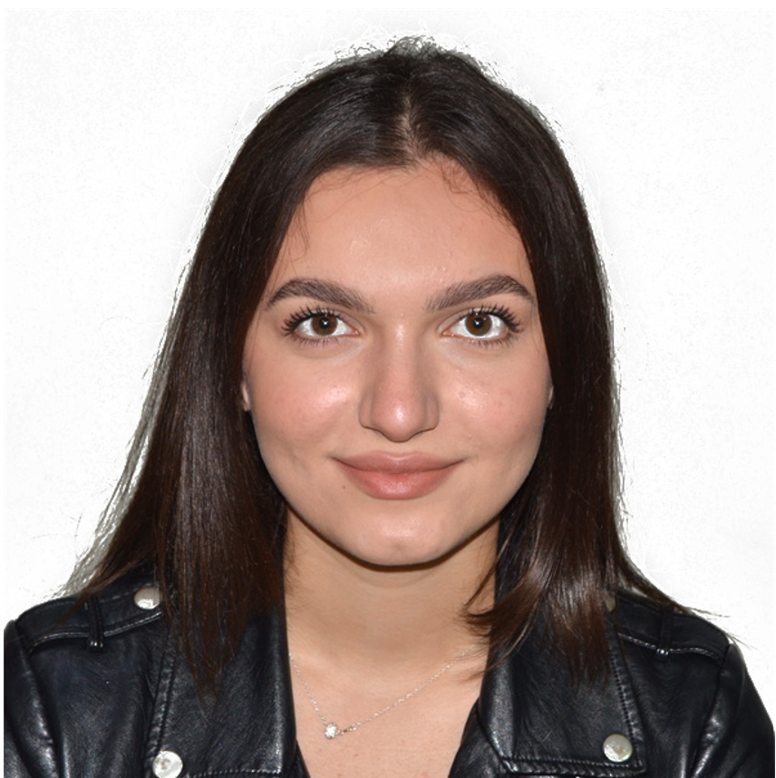 |  | yllka temaj  Third year student in branch-base and network management at Riinvest seeking employment and opportunities in the field of Information and Technology to learn and acquire new skills to be prepared for labor market.
Profile  Contact  PHONE:  (+383) 43 857 551  EMAIL:  Yllkaxtemaj@gmail.com  CITY:  Prishtine, KOSOVO |  | EDUCATION  College “Riinvest’ Prishtine  Software engineer-Network management  October 2019 - Continuous  High School “Gjon buzuku” Prizren  General science  September 2016 – June 2019  WORK EXPERIENCE  Down syndrome Kosovo [lecturer training]  April 2021- July 202  [Lecturer training for computer skills about office programs] Prishtine  SKILLS  • Good communication skills  [Language skills:  Albanian  English  Turkish]  • Computer languages  • Marketing  • Team worker  • Customer service  • Leadership.

