Europass  Curriculum Vitae |  | 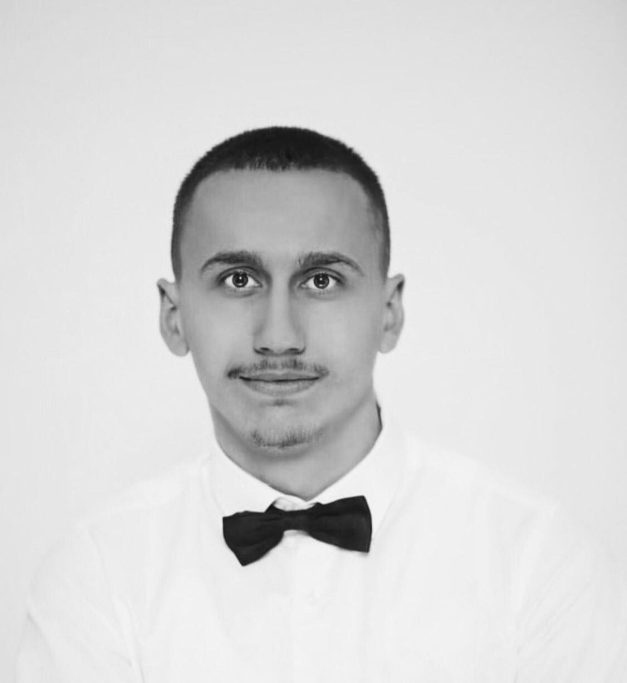
s
Personal information
First name(s) / Surname(s) |  | Ilir Misini
Address(es) |  | 24 Marsi,Dardania 2,Gjilan,Kosove.
Telephone(s) |  | 048 559 045
Fax(es) |  | ……………
E-mail |  | iilirmisini4@gmail.com , ilirmisini2004@gmail.com
Nationality |  | Albanian
Date of birth |  | 21.06.2004
Gender |  | Male
Objective

Work experience |  | ….…………
Dates |  | ……………
Occupation or position held |  | ……………
Main activities and responsibilities |  | …………….
Name and address of employer |  | …………….
Type of business or sector |  | ….…………
Education and training |  | Middle school,Faculty of Computer Science.
Dates |  | ….…………
Title of qualification awarded |  | ….…………
Principal subjects/occupational skills covered |  | ….…………
Name and type of organisation providing education and training |  | ….…………
Level in national or international classification |  | ….…………
Personal skills and competences |  | Critical-thinking , problem-solving,strong communication, leadership,time management,creativity,teamwork
Mother tongue(s) |  | Albania Language
Other language(s) |  | Specify language and evidence of skill level (language certificate)
Self-assessment |  |  | Understanding |  |  |  |  | Speaking |  |  |  |  | Writing
European level |  |  | Listening |  | Reading |  |  | Spoken interaction |  | Spoken production
Albanian |  |  |  | C2 |  | C2 |  |  | C2 |  |  | C2 |  | C2
English |  |  |  | B1 |  | B2 |  |  | B2 |  |  | B2 |  | B2
Social skills and competences |  | I have done many meetings in the IT field, AI development, and network field. I am a communicative person with others.
Organisational skills and competences |  | I’m motivated to always be with a great team to cooperate with others team or clients.
Technical skills and competences |  | Technical Writing,Coding,Network Configuration,Hardware Deployment,Operating System knowledge.
Computer skills and competences |  | ….…………
Artistic skills and competences |  | ….…………
Other skills and competences |  | ….…………
Driving licence |  | B
Additional information |  | ….…………
Annexes |  | ….…………

